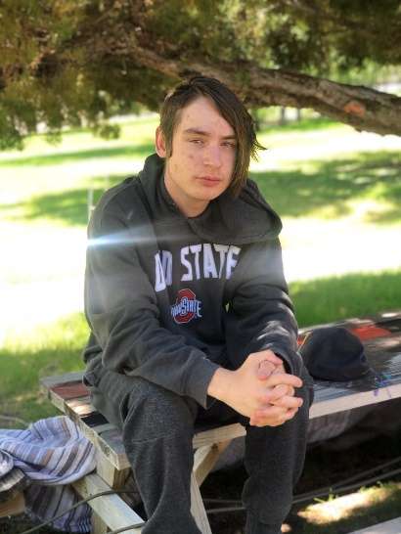

Richard
DOB: January 2004

Richard is an outgoing young man and he loves a good debate! Some of his hobbies are listening to music, drawing, playing soccer, riding a bike and text messaging and Facebooking with friends. When it comes to music, he is a big fan of Montana 300 and Lil Peep. Drawing is one of Richard’s biggest talents. It is very exciting and fulfilling for Richard to draw pictures for others and he has been able to sell some of his drawings! Richard has close family connections that he would like to keep.

If you are interested in learning more about Richard or the adoption process, please reach out to his recruiter at adoptionrecruiter@dcfs.nv.gov

