STATE OF NEVADA
ROMAINE GILLILAND
Director

Amber Howell
Administrator

BRIAN SANDOVAL
Governor

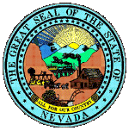

DEPARTMENT OF HEALTH AND HUMAN SERVICES
DIVISION OF CHILD AND FAMILY SERVICES
Children’s Mental Health

Acknowledgement Form

RE: SP-4 Documentation Policy (effective 01-27-15)

I acknowledge that I have received, read, and understand the above captioned policy(s) and related attachments.

I understand this signed statement will be placed in my Agency Personnel File.

______________________________________ _______________________________________
Print Employee’s Name Employee’s Signature

_____________________________________
Date

_________________________________ ___________________________________
Supervisor’s Signature Date

